الجمهورية اللبنانية
وزارة التربية والتعليم العالي الامتحانات الرسمية لشهادة الامتياز الفني
المديرية العامة للتعليم المهني والتقني لدورة عام 2012 الثانية
===============
الاختصاص والرمز : المعلوماتية الادارية (24004) –الانظمة والشبكات (24101)
المادة : التطوير التطبيقي بالانترنت – البرمجة بلغة انترنت المعدل: (8-6)
المستندات المسموح بها : لا شيء المدة : ساعة ونصف

N.B: All the "HTML" files are in the folder: \public
All the "AUDIO" and "VIDEO" files are in the folder: \waves
All the "IMAGES" files are in the folder: \pictures
All others files are in the folder: \public\misc
Gray Color value in hexadecimal is “C0C0C0”
Use the hexadecimal value with the colors.

I- Write the appropriate tags to obtain as a result the following page " camp.html" respecting the following conditions:  (3 pts)  - The title has the biggest possible size. Background color of the title is gray. The title color is white.  - The file « hello.wav » should be infinitely played when the mouse moves over the file.  - A click on this video « hello.wav » open the page « google.com »  - The image name is « email.bmp »  - A click on this image sends an email to the following address : « contactus@robinhood.org»  - When this page opens, and after 10 seconds, we should display the page « Available.htm » instead. | 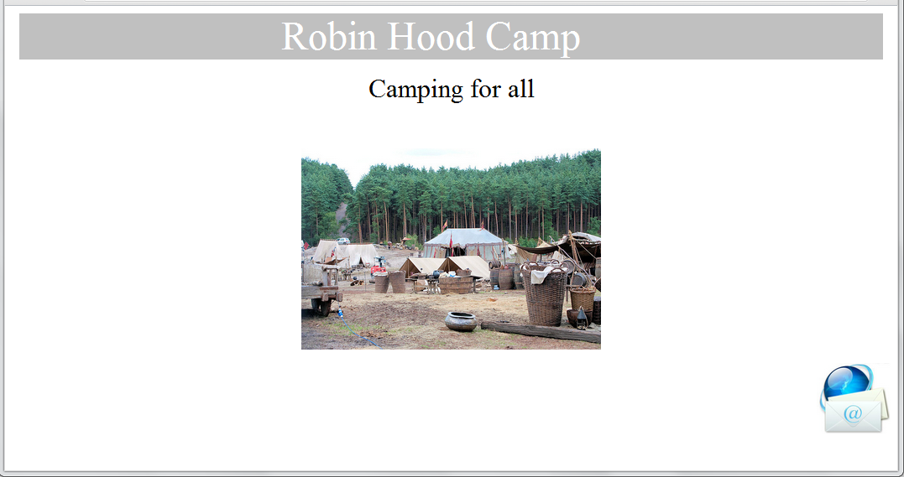
II- Write the appropriate tags to obtain as a result the following page " available.html" respecting the following conditions:  (4 pts)  - The table background is gray  - The table borders have two colors, green and red respectively.  - The table border thickness is 3 pixels.  - The table is aligned at the left of the page  - The distance between the text and the border is 1 pixel.  - The distance between the cells is 1 pixel.  - The image name is “climb.bmp”  - A click on « Full Price List » downloads the file « Robinhood.pdf ». | 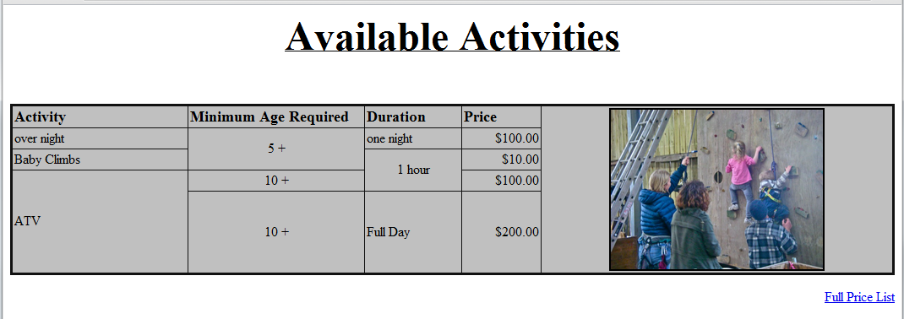

الاختصاص والرمز : المعلوماتية الادارية (24004) –الانظمة والشبكات (24101)
المادة : التطوير التطبيقي بالانترنت – البرمجة بلغة انترنت المعدل: (8-6)

 | III- Write the appropriate tags to obtain as a result the following page " request.html" respecting the following conditions:  (4 pts)  - F.Name: Entry field of 40 characters.  - Last Name: Entry field of 20 characters.  - Address: Entry field of 60 characters.  - Choice between « Male » or « Female »  - Choice between « 18+ » or «Under 18 »  - We can choose Join Group List » and « Receive Flyers » at the same time.  - Age: We can choose only one value from the following list « 5-», « 10-»,« 15-»,« 18-» and « above 18».  - Activity : We can choose only one value of the following values : « Over Night », « Baby Climb » and « ATV ».  - A Submit button that will send the values by email to the following address « form@robinhood.org »  - A Reset button to restore the original values. | 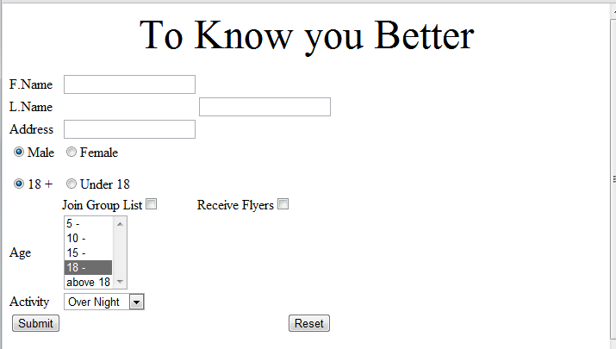
Frame A:
Width: 100 %
Height: 10%
IV- Write the appropriate tags to obtain as a result the following page " index.html" respecting the following conditions  (7 ½ pts)  - This page is divided into 3 frames A, B and C.  - The first frame display the scrolling message « Welcome to Roben Hood Camp » from left to right than from right to left infinitely.  - The second frame cadre "B" contains the following links:  - “Main” displays the page “camp.html” in frame C.  - “Activity” displays the page “ available.html ” in frame C.  - “Know you Better” displays the page “request.html” in frame C.  - “Facebook” displays the page “http www.facebook.com” in a new page.  - The third frame C displays by default the page “camp.html”  - Create all needed and not exiting pages, and add all needed tags to the existing pages. | 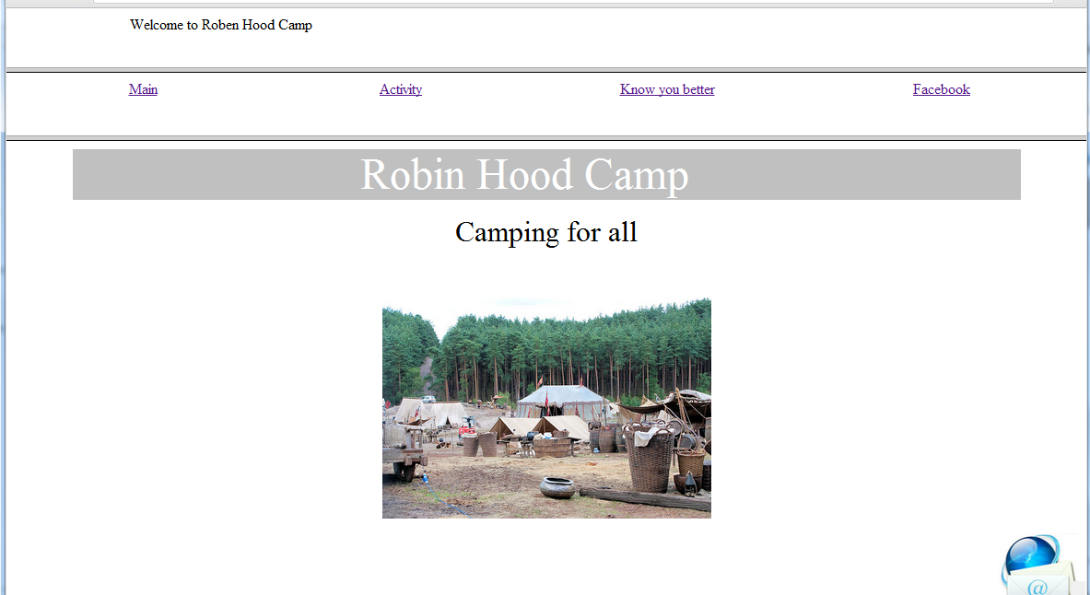  Frame B:  Width 100 %  Height:10%  Frame C:  Width:100 %  Height:80%
V. The administrator of this page realizes that the page loading is very slow.
- In your opinion, where is the error? Explain
- Give a solution.
(1 ½ pts)

